**Integrating Android studio with GitHub**

1. Install Git on local system

* Download the Git software (exe file) from below site and run the executable file.

<https://git-scm.com/>

* Open the GitBash terminal and check the version of Git to verify successful installation of Git.

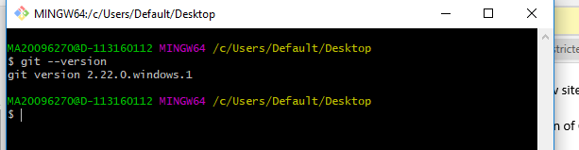

1. Set up the global configurations on the Git

* Open the GitBash and set user name, email Id etc.

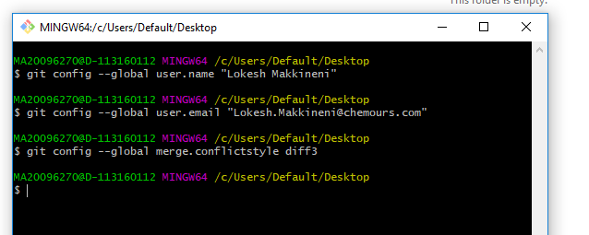

* Verify the configured details with the below command

git config –list

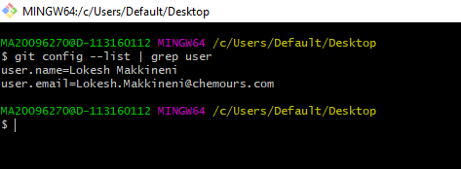

1. Generate the SSH Key
   * Open the GitBash terminal and execute the below command
     + ssh-keygen –t rsa –C “useremailid@chemours.com”

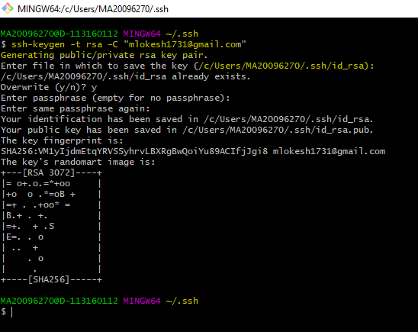

* + Copy the public key

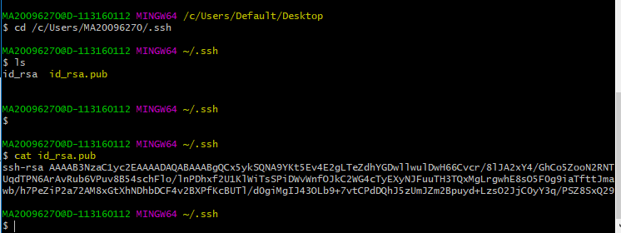

* + Add the SSH Key on GitHub Account.

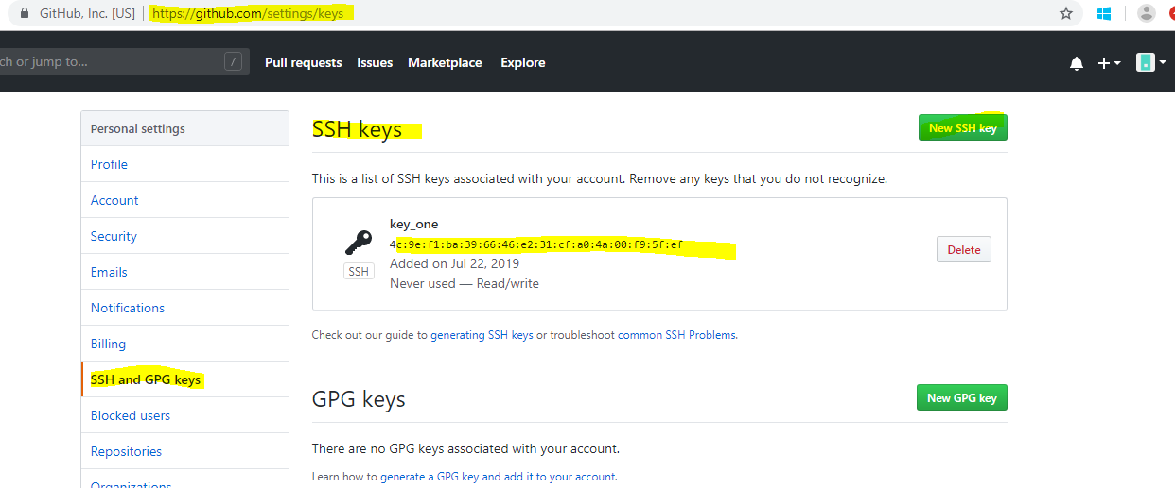

1. Access the Android studio and

* Now, go to ‘File’ –> ‘Settings’ –> ‘Version Control’ –> ‘GitHub’.

Add your GitHub credentials. And then click ‘Test’ to ensure that GitHub connection.

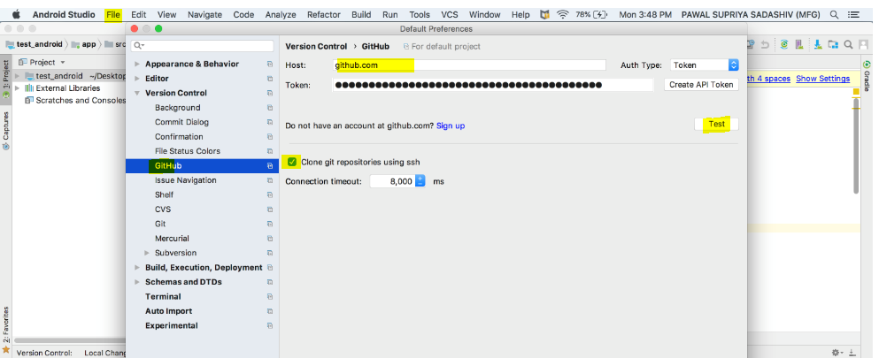

* Enable Version Control Integration

Select ‘VCS’ –> ‘Enable Version Control Integration…’ to enable version control for the current project.Choose the version control as GitHub.

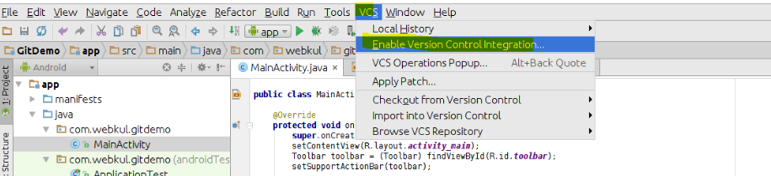

* Clone the repository from the GitHub

VCS 🡪 Checkout from version control 🡪 Git

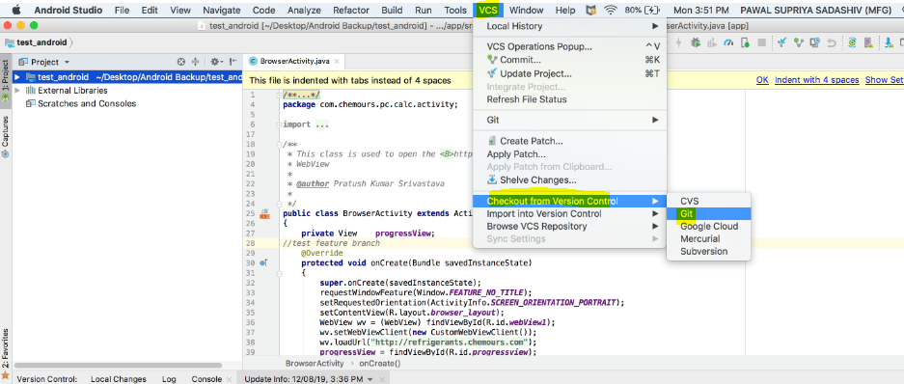

Provide Git repository URL and local path to clone.

* Checking out to required/working branch

VCS 🡪Git 🡪 Branches

Click on checkout as and select the branch to be checkout.

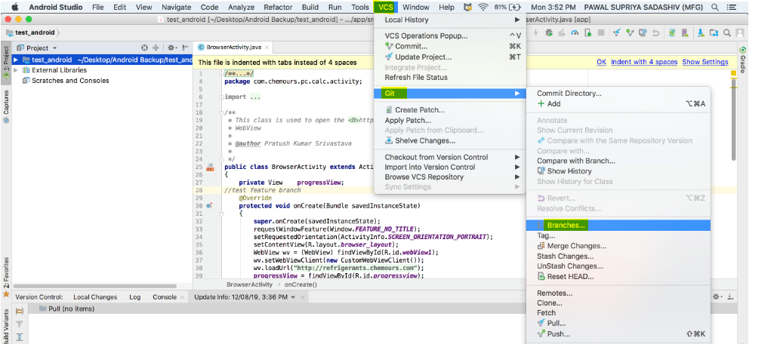

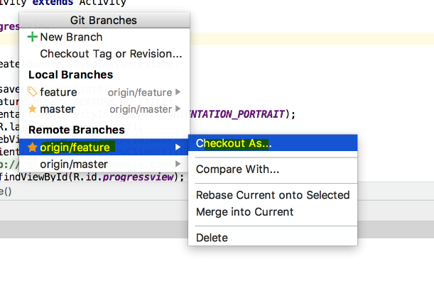

1. Git ADD and COMMIT

* Make Changes In The File And Pushing To The Repository

If we want to reflect any changes to our repository done in the project.to add any changes made, press VCS commit changes button (Ctrl +K) this will automatically add all the files after ignoring from the list of file mentioned in .gitignore.

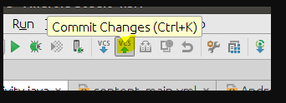

Provide proper commit message and select the files (click the check box) to be committed.

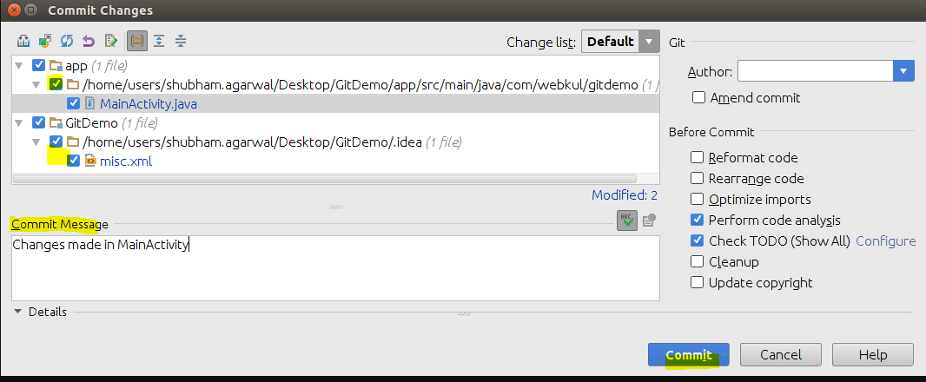

* PUSH and PULL

VCS 🡪Git 🡪 PUSH/PULL

